CSR Creation –

LB >> Traffic Management >> SSL >> SSL Files >>

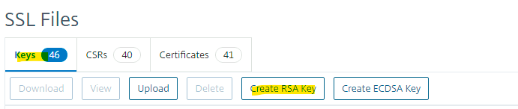

2048 for encryption.

Once done. Put common name with .key for Key Filename >> create.

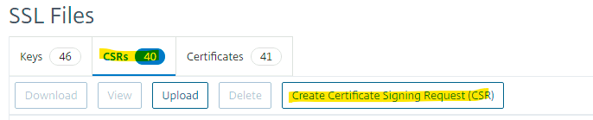

Request file name : url.csr

Keyfilename: url.key

SHA256

SAN name example :

DNS:stgeft.communitypass.mastercard.com DNS:stgeft.trianzsg.mccomcomnp.com (Cname = SAN Name)

Common name : stgeft.communitypass.mastercard.com (just url)

Organization name : MasterCard International Incorporated

State or Province : Waterloo

Courtry : BE

Create >> Validate in sslshopper site.